**Activities to Build ENGAGEMENT**

**Student Learning**

* School Site Council (SSC)
* English Learner Advisory Committee (ELAC)
* Parent/Teacher Conferences
* PTO Membership
* Back to School Night
* GATE Parent Meeting
* Parent Information Nights
* Open House

**Social-Emotional Development and Growth**

* Trunk or Treat Event
* Coffee with Admin
* Dances with Loved Ones
* Classroom Volunteering
* Parent/Teacher Conferences
* Family Nights
* Teacher Meet and Great Event

**Social-Emotional Development and Growth**

**Chino Valley Unified**

**School District**

**What is Home-School Partnerships?**

Home-School Partnerships is an agreement that parents, students and teachers develop together. It explains how parents and teachers will work together to make sure all students reach or exceed grade-level standards.

Effective compacts:

* **Link** to goals of the school's single plan for student achievement
* **Focus** on student learning skills
* **Describe** how teachers will help students develop those skills using high-quality curriculum and effective instruction in a supportive learning environment
* **Share** strategies parents can use at home
* **Explain** how teachers and parents will communicate about student progress
* **Describe** opportunities for parents to volunteer, observe, and participate in the classroom

**PARTNERSHIPS FAMILY PARTICIPATION**

**HOME-SCHOOL PARTNERSHIPS**

**for**

**STUDENT ACHIEVEMENT**

**2022-2023**

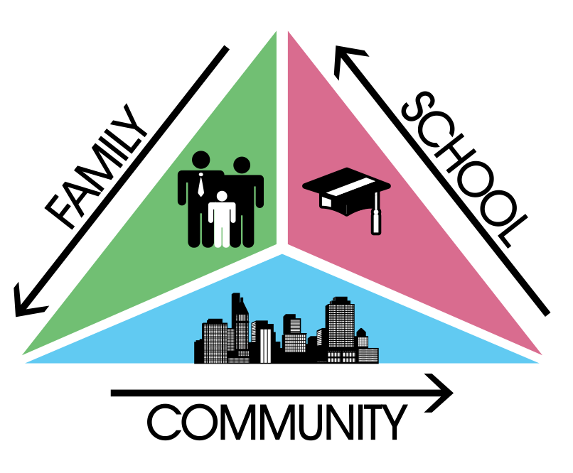

**Fifth Grade**

***Always walk through life as if you have something new to learn and you will.***

***Vernon Howard***

**E.J. Marshall Elementary**

**12045 Telephone Avenue**

**Chino, CA 91710**

**(909) 627-9741**

**Learning Compact**





**Communication about Student Learning**

Our school and families are committed to regular two-way communication about our children’s' learning. Some of the ways families and staff communicate all year are:

* **School to Home**
  + Monthly Newsletter
  + School website/email
  + Report cards and progress reports
  + Teacher-Parent Conferences
  + Aeries Parent Portal/Parent Square
* **Home to School**
  + Aeries Parent Portal/Parent Square
  + email
  + parent-teacher meetings
  + School Agendas
  + Phone Calls

**https://www.chino.k12.ca.us/Marshall**

**DISTRICT PARENT RESOURCES**

**Family Engagement Center**

**Adult School, Room 25**

**12970 Third St. Chino, CA 91710**

***WORKSHOPS PROVIDED:***

***EL PARENT ACADEMY***

***12 POWERS OF FAMILY BUSINESS***

***PARENTS AS PARTNERS***

***TRANSITIONS TO…..***

***COMPUTER LITERACY***

***FAMILY LITERACY PROJECT-COLLEGE AWARENESS***

**Family Engagement Center Link:**

**http://www.chino.k12.ca.us/Page/8882**

**909 628-1201 ext. 5601**

**(Spanish) 909 628-1201 ext. 5602**

**At Home**

**Here are some ideas of how families can support students’ success:**

* Talk with your child everyday about school
* Support children with homework as needed
* Ensure your child is in school, on time, everyday
* Report absences to the school as soon as possible
* Read to or have your student read (depending on ability) at least 30 minutes each night.
* Help your child organize school belongings
* Check your child’s school agenda each night
* Attend as many school events as possible, especially parent/teacher conferences and Back to School Night.
* Have your child speak to you in complete sentences.
* Read all school communication (email, website, Parent Square, etc.)
* Practice basic addition, subtraction, multiplication, and division facts (depending on grade level) each night.
* Practice grade level site words each night (primary grades).
* Monitor your child’s screen time and ensure healthy eating habits and sleep time.
* Play board games which encourage language development and vocabulary along with social family time.

**In the Classroom**

**As a Fifth Grade teacher, I will engage all students with a vibrant learning climate and high-quality instruction. Listed below are some of the student learning strategies your child will use this year.**

Goal #1 and 3:

* Students will succeed in meeting the Common Core State Standards.
  + Daily writing across all curricular areas using thinking maps.
  + Focused and clear writing for a purpose.
  + Daily questioning addressing the Depth of Knowledge levels 1-4.
  + Cite textual evidence through informational reading.
  + Focus on the 4C’s (Communication, Collaboration, Critical Thinking and Creativity).
  + Focus on Standards of Mathematical Practices.
  + Focus on Math Problem Solving Strategies.
  + Learning through productive struggle.

Goal #2:

* Reinforce PBIS strategies
* Use Second Step curriculum daily
* Keep an open communication line with parents and ensure all students are utilizing school agendas.
* Provide parents and students periodic feedback on progress and performance.

**Learning Compact**

**Teachers, Parents, Students Shared Responsibility for Learning**

**District Goals - Local Control Accountability Plan (LCAP)**

All students are provided a high-quality teaching and learning environment.

Staff, parents, families, and students are connected and engaged at their school to ensure student success.

All students are prepared for college and career beyond graduation.

**School Goals**

**GOAL 1**

All students are provided a high-quality teaching and learning environment.

**GOAL 2-**

Staff, parents, families, and students are connected and engaged at their school to ensure student success.

**GOAL 3-**

All students are prepared for college and career beyond graduation.

*Our school provides high quality curriculum and instruction in supportive and effective classroom environments to enable students to meet state academic standards. We support our students and work hard to provide a welcoming, safe school environment.*

**Our Goals for**

**Student Achievement**